BME 301 Name:
Exam 1
February 12, 2004

The exam consists of 10 questions. Show all work to receive credit. Clearly organize your work and draw a box around your final answers. NEATNESS COUNTS! Good Luck!

Problem 1 (5):

Problem 2 (5):

Problem 3 (20):

Problem 4 (10):

Problem 5 (20):

Problem 6 (5):

Problem 7 (5):

Problem 8 (10):

Problem 9: (10):

Problem 10 (10):

Total (100):

- a) Which would you expect to be higher: the incidence of the flu or the prevalence of the flu? Why?

I would expect the incidence of the flu to be higher because it is a relatively short duration disease; people soon recover.

- Which would you expect to be higher: the incidence of HIV/AIDS or the prevalence of HIV/AIDS? Why?

I would expect the prevalence of HIV/AIDS to be higher because it is a relatively long duration disease; people don’t recover.

- Discuss three advantages and three disadvantages of the single payer Canadian system of health care financing to that of the multi-payer US system of health care financing.

Advantages: 1) everyone is insured and has access to basic medical care, 2) administrative costs are lower, 3) system is popular and simple

Disadvantages: 1) sometimes have to wait for services, 2) physician incomes are capped, 3) do not have access to some high tech developments (MRIs)

- Use the information in the chart to answer the questions that follow.
Country | Population | Gross Domestic Product (GDP)  Per Capita | Total Health Expenditure Per Capita | Estimated annual incidence rate of tuberculosis per 100,000 population
Brazil | 172,558,000 | $7,548 | $631 | 64
India | 1,025,095,000 | $1,461 | $71 | 178
Uganda | 24,022,000 | $932 | $36 | 324
(a) For each of the three countries shown, calculate the approximate number of new cases of tuberculosis each year.
Brazil: (172,558,000)(64/ 100,000) = 110,437 new cases
India: (1,025,095,000)(178/100,000) = 1,824,669 new cases
Uganda: (24,022,000)(324/100,000) = 77,831 new cases
(b) Make a graph that shows estimated annual incidence rate of tuberculosis (per 100,000 population) vs. total health expenditure per capita for these three countries. Include a title and labels.
Uganda
India
Brazil
(c) For each of the three countries shown, calculate the percentage of the gross domestic product (GDP) that is spent on health expenditures.
Brazil: ($631)/($7548) = 8.4% India: ($71)/($1461) = 4.9%
Uganda: ($36)/($932) = 3.9%
(d) Make a graph that shows percentage of GDP spent on health expenditures vs. GDP per capita for these three countries. Include a title and labels. Based on your knowledge of the U.S. health care system, describe where you think the United States would lie on this graph.
US would have high % of GDP spent on health (13%) and high GDP per capita (>$20k).
- The graphs below show how the incidence rate and the mortality rate for breast cancer have changed over the past 25 years. Between 1980 and 1987, incidence increased almost 4% per year.
  - What was the most important factor contributing to this increase in incidence?

During this period, better screening and detection methods were implemented so more cases were detected.

  - Since 1989, the mortality rate of breast cancer has been decreasing among Caucasian women. What are the most important factors which have contributed to his decrease?

Better detection has meant that more breast cancer is diagnosed at an early stage when it is still curable.

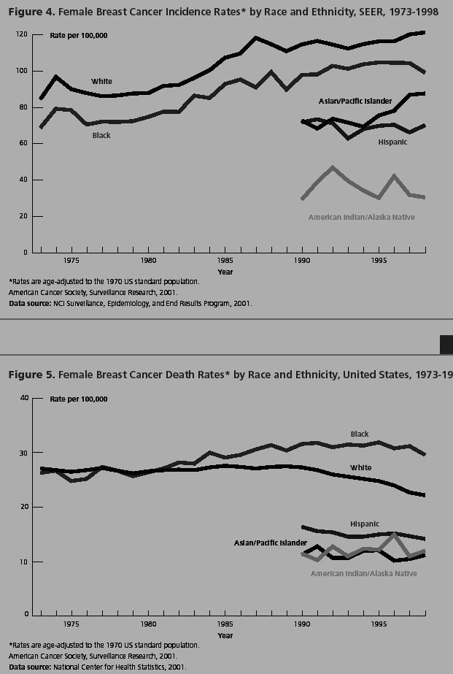
- When detected early, ovarian cancer is curable for 95% of women. Unfortunately, in the majority of cases, ovarian cancer is not detected until widespread metastasis has occurred. In this circumstance, ovarian cancer is fatal approximately 63% of the time. The American Cancer Society estimates that there will be about 25,580 new cases of ovarian cancer in the United States in 2004. About 16,090 American women will die of the disease in 2004. On average, 22 years of life are lost when a woman dies of ovarian cancer. You have developed a new blood test that can detect ovarian cancer in the earliest possible stages. Each blood test costs $200 to perform. There are 292 million Americans, approximately 70 million of whom are women over age 40.

  - How much money would we spend annually if all women over age 40 were screened with this new test?

Total spent = (70,000,000 women)x($200 per test) = $14 billion

  - Calculate the annual mortality rate of ovarian cancer without the use of the new test. Compare this to the expected annual mortality rate of ovarian cancer with the use of the new test.

Without: Mortality rate = (25,580 cases)(.63)/292,000,000 = 5.5 x 10⁻⁵ = 5.5 per 100,000
With: Mortality rate = (25,580 cases)(.05)/292,000,000 = 4.3x10⁻⁶ = 4.3 per 1,000,000

  - If the new test was used, how many years of life would be gained?

Without: Years lost = (25,580)(.63) deaths x 22 years lost = 354,539 years lost
With: Years lost = (25,580)(.05) deaths x 22 years lost = 28,138 years lost

Years gained = 354,539 – 28,138 = 326,401 years gained

  - If this test was administered annually to all women over age 40, how many $ would we spend per year of life gained?

$/year of life gained = $14 billion/326,401 years = 42,892 per year of life gained

  - Based on your answer to part d and our discussions in class, do you think this test would be adopted in the developed world? In the developing world? Explain your reasoning.

Developed world: yes because it is less than $100,000 per year of life gained
Developing world: definitely no because the cost of the test exceeds the total amount spent on health care per capita in many developing countries. The Pap smear, which costs less than this, and is equally effective, is not used in many developing countries.

- Describe the clinical course of HIV infection, including the major steps from initial infection to full-blown AIDS.

HIV Infection →Virus deposited on mucosal surface →Acute infection (mono-like symptoms) →Viral dissemination →HIV-specific immune response→Replication of virus→Destruction of CD4+ lymphocytes (Latent Period)
AIDS→Immunologic dysregulation→Opportunistic infections and cancers→Risk of infections is correlated with number of CD4+ lymphocytes→Average patient with AIDS dies in 1-3 years

- The figure below shows the major steps that occur when HIV infects a CD4+ lymphocyte. Three types of drugs have been developed to fight HIV infections. Indicate on the figure where in the viral life cycle these three types of drugs act. In one sentence each, describe how the drugs work.
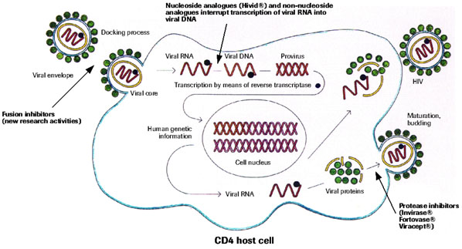

- What are the four major types of health insurance plans? Give a one-sentence description of the features of each one.

- Conventional insurance – You to go to any primary care doctor, specialist or hospital that you choose; after your deductible is met, your health plan pays for a percentage of your healthcare expenses (usually 80 percent).
- HMO – Health Maintenance Organization -Your medical care is supervised by your primary care doctor, who must authorize access to specialists; you pay a small copayment ($5, $10 or $15) for each visit or service instead of a deductible and coinsurance.
- PPO – Preferred Provider Organization – providers (hospitals, physicians, and other healthcare practitioners) agree to provide services at negotiated fees; you are allowed to go to out-of-network providers, but you receive greater benefits if you stay within the network. Generally, you have direct access to specialists.
- POS – Point of Service Plan - POS plans combine features of both HMO and PPO plans; you can choose how you access the plan each time you need treatment. If you choose to use the HMO network, your PCP coordinates care, and your out-of-pocket costs are minimal. If you choose to go outside the HMO network for care, you may select your physician, but you will have to pay deductible and coinsurance charges.

- High dose chemotherapy followed by bone marrow transplant is an example of a therapy that initially generated much excitement and hope, but was later found to not be effective.

  - Why did people initially believe that high dose chemotherapy would be effective for metastatic breast cancer?

It appeared that women with metastatic breast cancer who received higher doses of chemo responded better. Early phase II trials of very high dose chemo followed by bone marrow transplant (which were not randomized) showed promising results.

  - Why is a bone marrow transplant necessary following high dose chemotherapy?

Because high dose chemo kills bone marrow cells. The bone marrow is responsible for regenerating cells of the blood, including oxygen providing red blood cells and infection fighting white blood cells. Without bone marrow, a person will rapidly die, so it must be replaced.

- Health care costs have risen dramatically in the US. At the same time, the number of people without health insurance has been rising. A number of plans to reform health care have been proposed in response to these pressures.

  - What are the three major factors currently responsible for increases in health care costs in the United States?

Any of the following are acceptable: Aging population, use of technology, prescription drug costs, administrative costs

  - Whether health care reform in Oregon was a success or not has been the subject of much debate. Give two arguments for each side.

Success: 1) expanded insurance coverage for poor; 2) expanded number of services that were covered; 3) reduced low birth weight babies and ER visits
Failure: 1) did not really save money; 2) did not really ration care
EXTRA CREDIT:

- Is the fish tank in Dr. Richards-Kortum's office a fresh or salt-water tank?

SALT

- Who is on the front of the BME301 official t-shirt?

Former surgeon general C. Everett Koop

- What is the saddest book that Dr. RRK has ever read?

A Map of the World by Jane Hamilton

